REPORT OF LIBRARY MANAGEMENET SYSTEM

Mini project : Week 3 Progress Plan
Name : Param Changotra

1. Objective

The main objective of the Library Management System is to digitize library operations so that book records, user records, issue/return transactions, and reports can be managed accurately and efficiently. The system reduces manual paperwork, lowers errors, improves search speed, and gives both administrators and users faster access to library information. It also supports secure, role-based access so that students and admins see only the functions relevant to them.

2. Milestones

The milestones show the key achievements completed during Week 3 of the project. These include creating the project structure, developing the basic prototype, implementing the core modules, and testing the system with sample book records. Completing these milestones ensures the project is on track and ready for further development in Week 4.
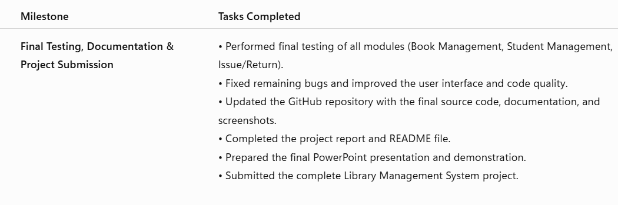

3. Modules

The LMS is typically divided into Admin and Student/User modules, with the admin handling core library operations and the student side supporting self-service actions. Common admin functions include adding, updating, and deleting books, categories, and authors, plus issuing and returning books and managing student records. Common student functions include registration, login, viewing available books, checking issued books, updating profile details, and changing or recovering passwords.

4. Data storage and Flow

The project stores data in relational tables such as admin, authors, books, categories, issued books, and students, which supports normalization and reduces redundancy. Input processing usually begins with login forms, book entry forms, student registration forms, and issue/return actions; the backend validates the input and writes or reads records from the database. Output generation includes dashboards, book lists, issued book views, transaction summaries, and reports such as borrowed, returned, and overdue items.

5. GitHub and Organisation

For GitHub organisation, the project should be structured into clear folders such as includes/, assets/, admin/, student/, database/, and docs/ so the codebase is easy to maintain. Main files should be separated by purpose, for example authentication pages, dashboard pages, management pages, and reusable components like header, navbar, footer, and configuration files. A clean repository should also include a README, setup instructions, and screenshots of the main pages.

6. TESTING AND CURRENT PROGRESS

Testing should cover login validation, session handling, CRUD operations, book issuance, returns, fine calculation, and report accuracy. Unit testing can check individual functions and form validations, while integration testing should confirm that the frontend, backend, and database work together correctly. A useful test case is checking whether an issued book changes from “available” to “borrowed,” and then returns to “available” after being returned. Furthermore, The current progress can be described as having the core LMS structure in place: login pages, dashboards, book management, issued-book tracking, and database-linked lists are already developed or partially developed. The project also appears to have a working admin/user split, which is a strong sign that the base architecture is ready. At this stage, the main work is likely refinement, testing, and documentation.

7. CHALLENEGES AND WEEK 4 PLAN

Typical challenges include ensuring correct database relationships, keeping issue/return status synchronized, avoiding login/session bugs, and maintaining accurate fine calculations. Another challenge is making the UI simple enough for users while still keeping admin functions powerful and efficient. Because the system is web-based, it also depends on stable connectivity and a properly configured server environment. Moreover, Week 4 should focus on final integration, bug fixing, testing, report completion, and presentation preparation. The final build should be checked for broken links, incorrect SQL queries, inconsistent table data, and edge cases such as invalid login or duplicate records. By the end of Week 4, the project should be demo-ready with polished pages, tested workflows, and complete documentation.

